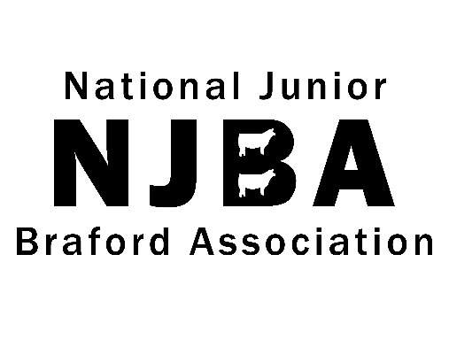

UBB Youth Ambassador Application
The National Junior Braford Association Ambassadors are selected to serve a one year term representing the Braford breed. Ambassadors provide the United Braford Breeders with assistance in show coverage at the five national open Braford shows (Houston Livestock Show and Rodeo, Four State Fair, Louisiana State Fair, Fort Worth Stock Show and Dixie National Livestock Show) and event management at special events like the UBB annual meeting, the All American, etc. Ambassadors are expected to be dressed neatly and represent the Braford breed in a professional manner at all times.
Application Qualifications
1. Applicant must be a member of the National Junior Braford Association.
3. Applicant must be able and willing to represent the National Junior Braford Association at the 2017 – 2018 National Braford Shows.
4. Applications must be submitted via email to ubb@brafords.org by June 1. All parts must be completed and a color photo of applicant should be submitted with application.
6. In-person ambassador interviews will take place at the All American.

NJBA Ambassador Application
Applications must be submitted by June 1
Name: Age:
Address:__________________________________________________________________________________________________________________________ Phone Number:________________________________________________________E-mail:__________________________________________________
Years in NJBA:___________________________ Years in 4-H: ___________________________ Years in FFA: _____________________________
Please provide us with a brief summary of your involvement in the NJBA or beef industry.

Why do you want to be a Braford Ambassador?

What is one characteristic that you believe every leader should possess?

Why should you be chosen as a recipient of this honor?

Describe your career, educational, and personal goals that you would like to achieve in the next 5 years and your plan for attaining them.

Please submit by June 1 with a color photo to:
National Junior Braford Association
ubb@brafords.org

